USER MANUAL for SALK APPLICATION

***User Type- Coordinator***



**Consulting & Technology by**



**ANDOLA SOFT Pvt. Ltd**

|  |  |
| --- | --- |
| **S3/A-65, Mancheswar Ind Est., Bhubaneswar, Odisha, 751010 Ph-+91 674 258 7439/40** | ***Document Prepared By:***  **Shree Mishra**  **Sr. Business Analyst**  **ANDOLA SOFT** |

Table of Contents

1.0 Introduction to Application 3

2.0 Create New Coordinator 4

3.0 Coordinator Log In 5

4.0 The Dashboard 6

5.0 Research Area *(add a new research)* 7

6.0 Research Area *(Post a new research)* 10

7.0 Add Questionnaire 11

8.0 View Participant 13

9.0 View Feedogram 14

10.0 View Food Log 15

11.0 View Weekly Chart 17

12.0 View Tag Cloud 19

13.0 View Health Charts 20

13.1 Weight 20

13.2 Blood Pressure 21

13.3 Sleep Timing 22

13.4 Blood Sugar 23

14.0 View Maps 24

15.0 View Calendar 25

16.0 View Blood Collection Centers 26

16.1 Add New Blood Collection Center 27

17.0 View Reports 28

17.1 Daily Report 28

17.2 Weekly Report 28

# 1.0 Introduction to Application

# 2.0 Create New Coordinator

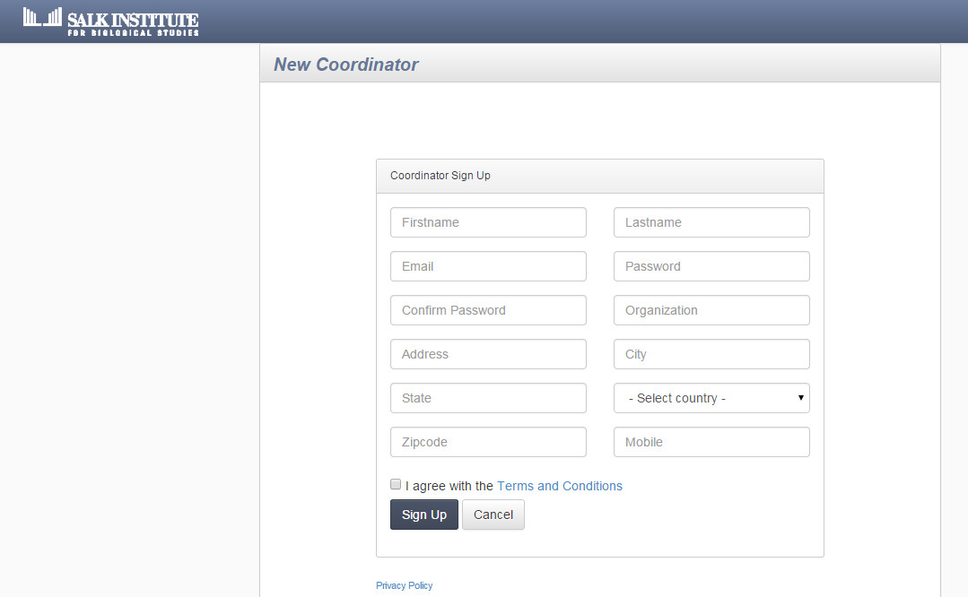

|  |  |
| --- | --- |
| Form Name | New Coordinator Sign Up |
| Form to be Used by | Coordinator |
| Form Functionality | When a new coordinator decides to join the SALK application he needs to visit the “New Coordinator Sign up” page. Once the details of the form are filled out such as name, mail id, password etc (shown in the image above), coordinator needs to press the sign up button. A notification will be sent to administrator’s dashboard. The admin has to accept the request of the coordinator. When acceptance process is completed a mail is sent to the coordinator. Coordinator needs to log in to his mail id and click on the link as sent by admin. Upon doing do he becomes a registered member of the application. The next step will be to log in to the system using his mail id and password. This screen has been shown below. |
| Form Output | When Cancel button is pressed the form moves back one page. When sign up is pressed a notification is sent to admin’s dashboard. |

# 3.0 Coordinator Log In

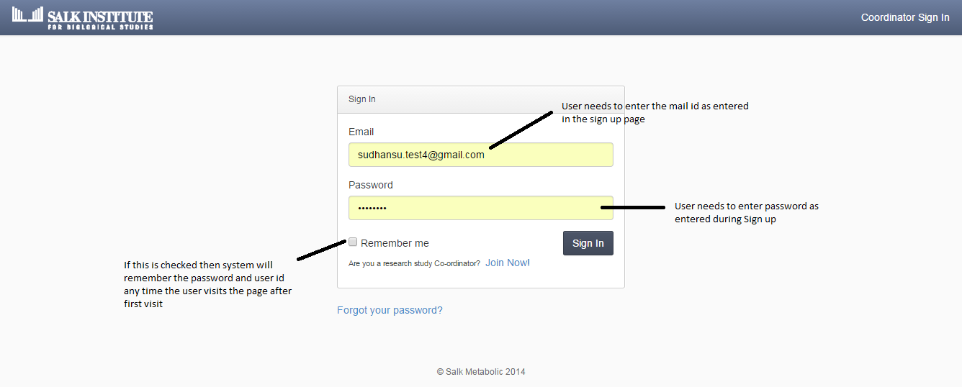

|  |  |
| --- | --- |
| Form Name | Coordinator Log In |
| Form to be Used by | Coordinator |
| Form Functionality | Coordinator needs to enter his email id and password in order to access his account. A forgot password option is also given incase the user forgets his password. Upon clicking the button a separate page will open asking user to enter his mail id. When mail id is entered a password reset link will be sent to his mail id. |
| Form Output | Upon entering the correct credentials user will be re directed to his account |

# 4.0 The Dashboard

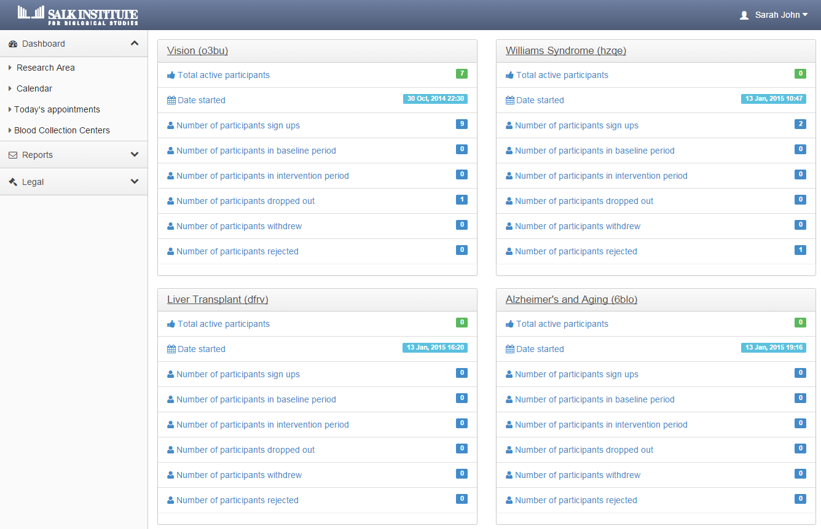

|  |  |
| --- | --- |
| Form Name | Coordinator dashboard |
| Form to be Used by | Coordinator |
| Form Functionality | Coordinator will be able to view the researches which he has created, the number of active, inactive, rejected, drop out, withdrew participants. The left hand side menu shows the menus. Coordinator needs to go to Research Area Menu to create a new research. This functionality will be shown in the next screen. |
| Form Output | This form is used for viewing purpose. |

# 3.png5.0 Research Area *(add a new research)*

This screen appears on clicking the Menus Research Area. Here the Coordinator will be able to view Active/ Inactive/Completed/Request for approval researches. However if the coordinator is a first time user or he wishes to create a new research he may press the “ADD Research” button present on top right hand corner of screen. The next screen shows the page which will appear upon clicking the Add Research Button.

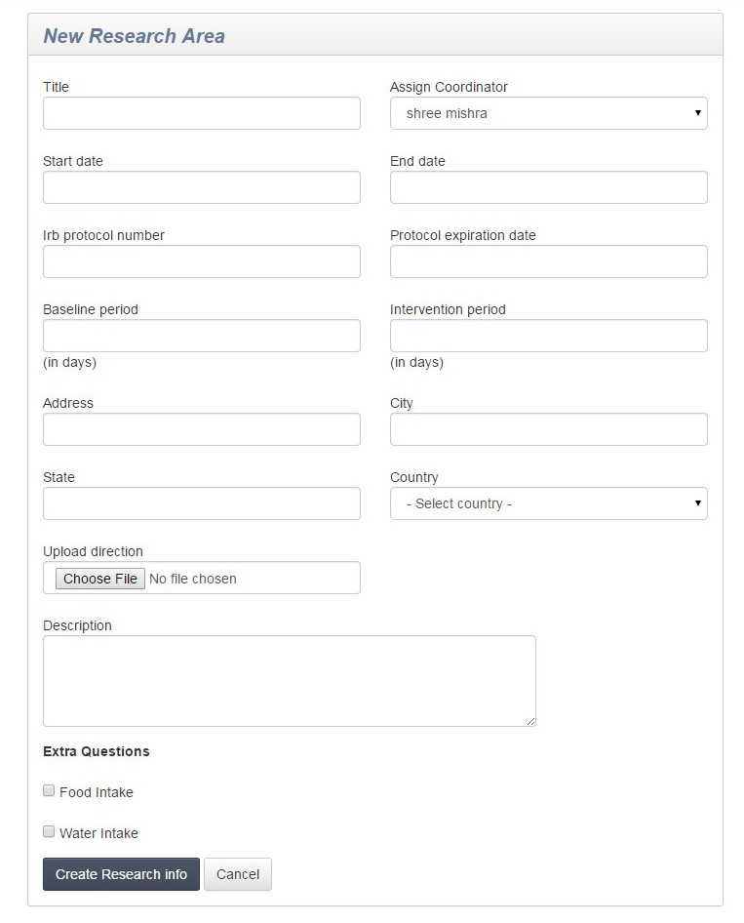

|  |  |
| --- | --- |
| Form Name | New Research Area |
| Form to be Used by | Coordinator |
| Form Functionality | Coordinator needs to fill out details as shown in the above form. Detail such as name of the research, start date, end date, IRB Number, base line duration, intervention duration etc. Coordinator also needs to add a .jpg fil of the direction of the institute, description of the research |
| Form Output | This form is has two buttons, “Create Research Info” & “Cancel”. Create Research Info will send a notification to admin regarding creation of a new research. Unless the admin accepts the research it will remain inactive and coordinator will not be able to post any advertisements. When the admin accepts the research, the status of the research shall change to Active and coordinator can post advertisement. This feature will be shown next. Cancel button will be used to navigate a page back. |

# 6.0 Research Area *(Post a new research)*

|  |  |
| --- | --- |
| Form Name | Add Research Ad |
| Form to be Used by | Coordinator |
| Form Functionality | Coordinator needs to fill out details as shown in the above form. Detail such as name of the research, start date, end date, of the advertisement and a brief description. |
| Form Output | This form has two buttons, “Create Research Info” & “Cancel”. Create Research add will re direct user to enter all relevant details of the ad such as  Who is Eligible to Participate  About This Study  How this Study Works  Who is Running this Study  Cancel button will go back a page back. |

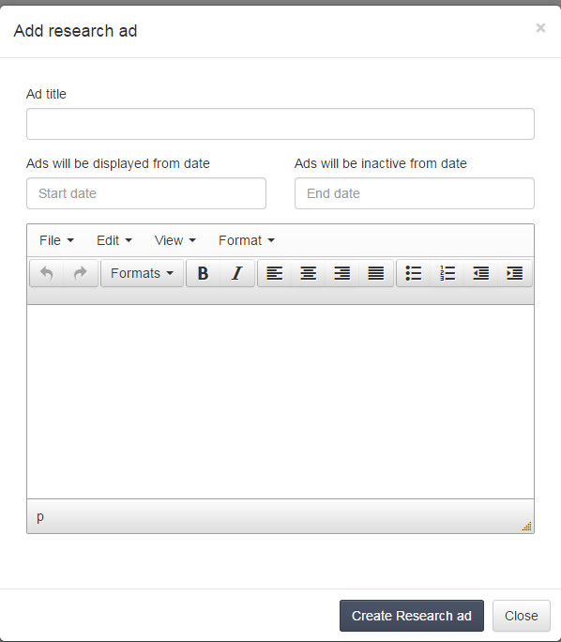

# 7.0 Add Questionnaire

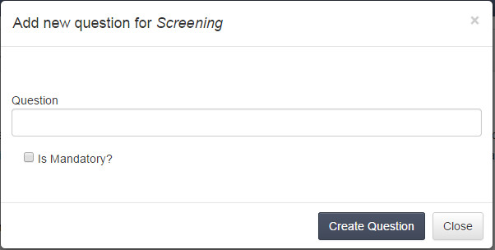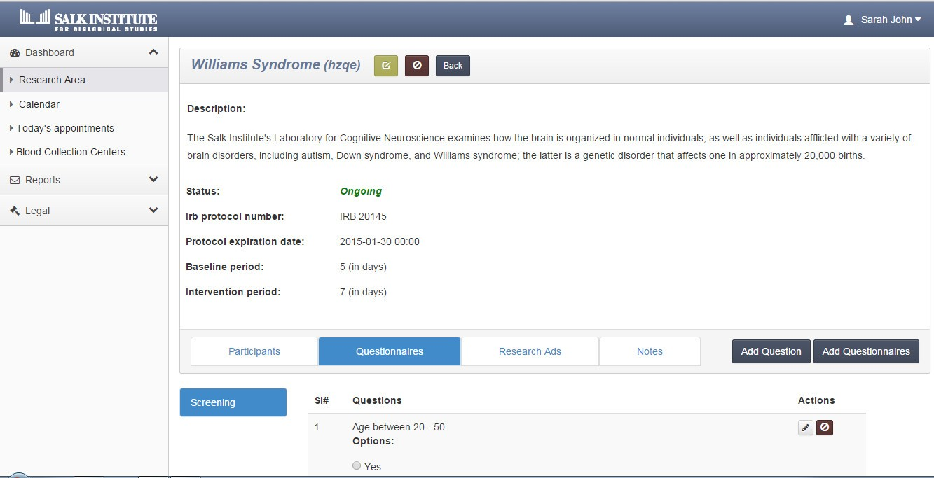

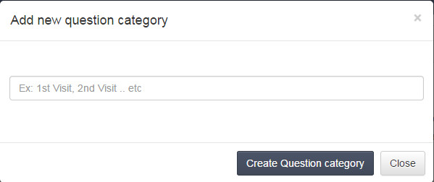

|  |  |
| --- | --- |
| Form Name | Questionnaire |
| Form to be Used by | Coordinator |
| Form Functionality | After the coordinator has filled out details of his research he needs to navigate to “Questionnaire” tab as shown in the first image. He will then have option to add questionnaire using the tab present in right hand side. He needs to add visits that are to be done by participant. All visits will get added under screening section as shown in first image. Then coordinator needs to add questions which get displayed besides screening as shown in first image. “ADD QUESTIONNAIRE” AND “ADD QUESTIONS” SCREENSHOT has been shown subsequently. |

# 8.0 View Participant

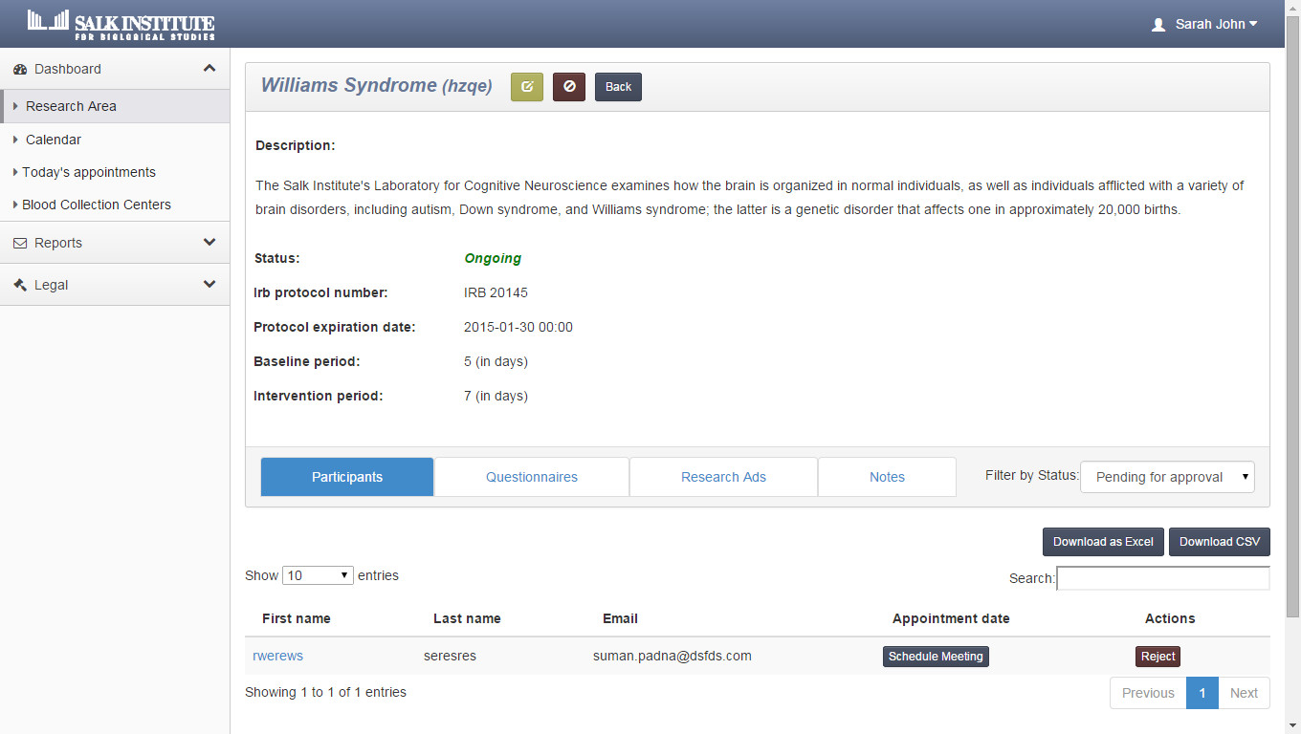

|  |  |
| --- | --- |
| Form Name | Participant |
| Form to be Used by | Coordinator |
| Form Functionality | Coordinator can see the list of participant for a particular study. A filter is present on the screen “Filter by status”. The various status present are   * Pending for approval * Approved * Rejected * Drop out * Withdraw * Screening   Based on the selection made by the coordinator the list will appear. Once the coordinator decides to approve a participant, he has to schedule a lab visit for him. Once the participant accepts the date he will be available on the day of visit and if the participant does not accept the date he may reject it and coordinator will have the option to reschedule. |
| Form Output | Depending on the selection made in the filter the list will appear accordingly.. |

# 9.0 View Feedogram

|  |  |
| --- | --- |
| Form Name | Feedogram Tab |
| Form to be Used by | Coordinator |
| Form Functionality | The Coordinator will be able to view each participant’s Feedogram. Various filter options are available for him to choose from. Coordinator may select “Baseline” or “Intervention”, duration and the Feedogram will appear accordingly. Mouse over on the points will display the food which the participant has taken along with the image. There is a dropout option as well. Coordinator may click on that button to opt to drop a participant. |
| Form Output | Depending on the selection made in the filter the feedogram will appear accordingly.. |

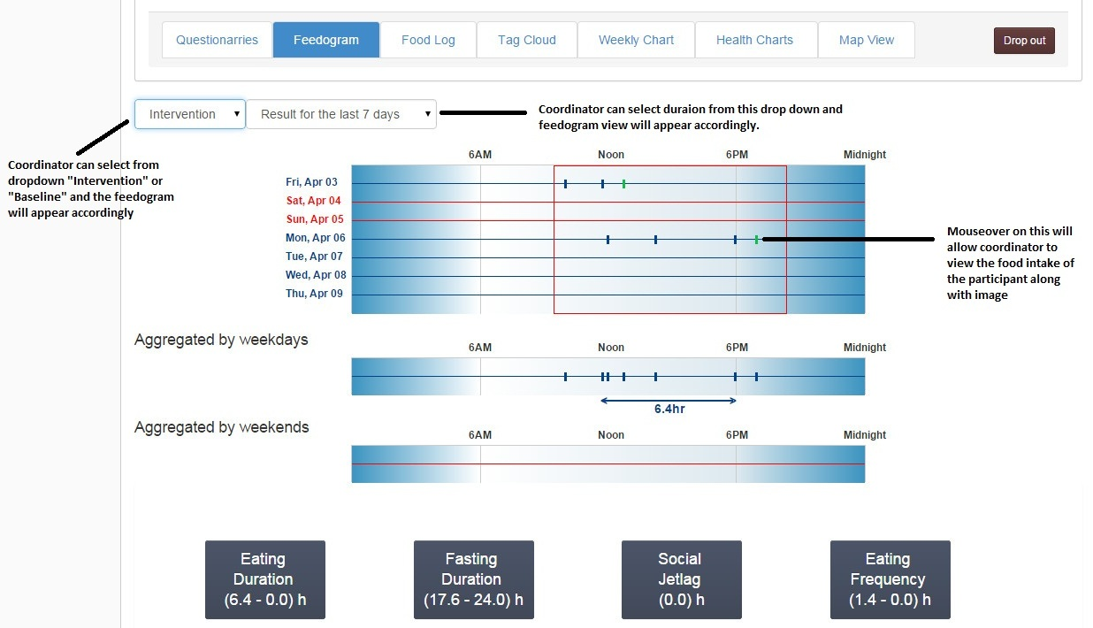

# 10.0 View Food Log

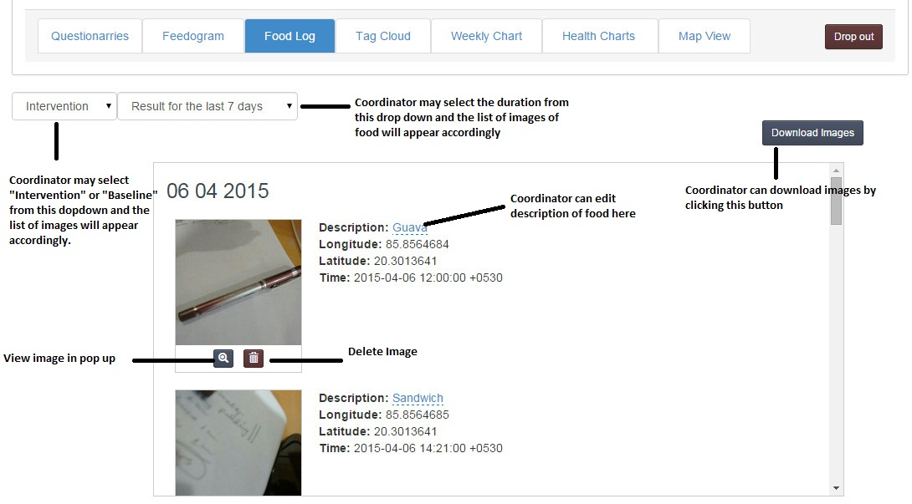

|  |  |
| --- | --- |
| Form Name | Food Log Tab |
| Form to be Used by | Coordinator |
| Form Functionality | The Coordinator will be able to view each participant’s Food log. Various filter options are available for him to choose from. Coordinator may select “Baseline” or “Intervention”, duration and the Food log will appear accordingly. There is a dropout option as well. Coordinator may click on that button to opt to drop a participant. |
| Form Output | Depending on the selection made in the filter the Food Log will appear accordingly. |

# 11.0 View Weekly Chart

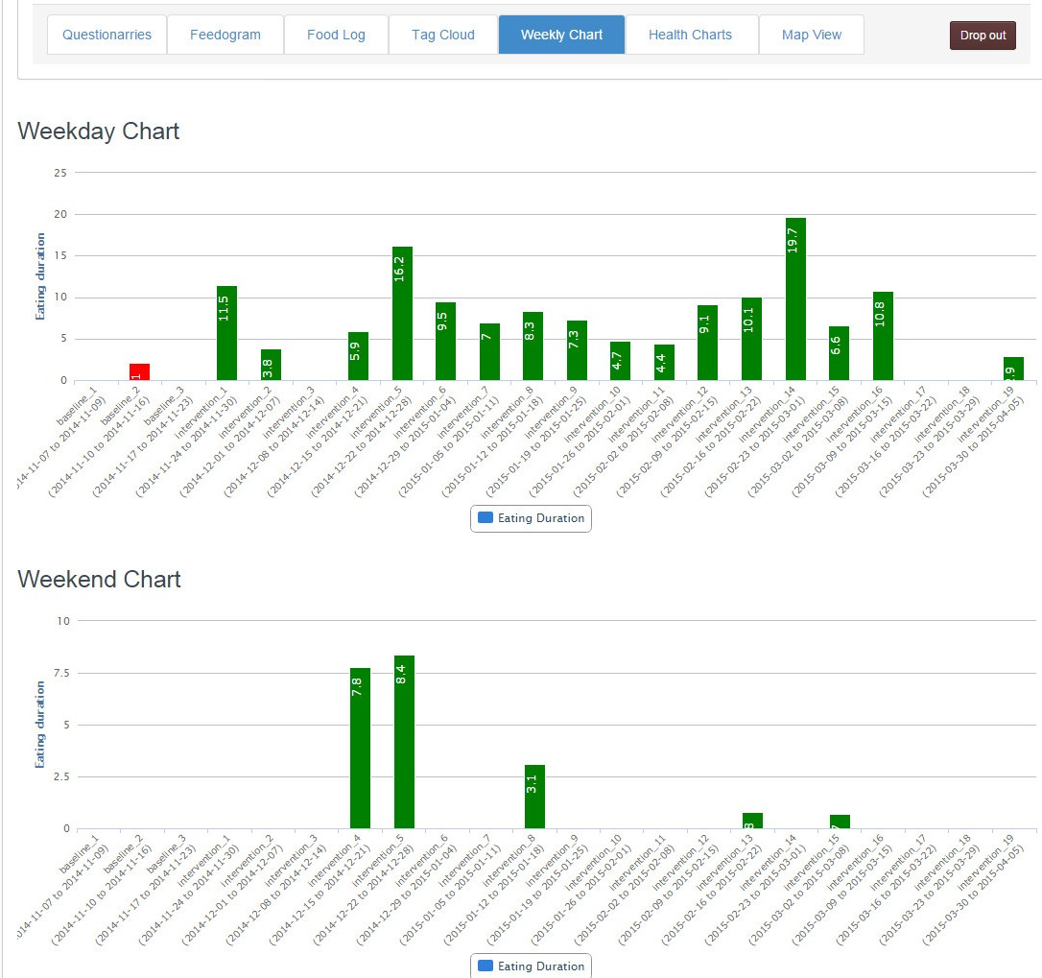

|  |  |
| --- | --- |
| Form Name | Weekly Chart Tab |
| Form to be Used by | Coordinator |
| Form Functionality | The Coordinator will be able to view each participant’s Weekly food chart.. |
| Form Output | Viewing of chart week and weekend wise. |

# tagcloud.jpg12.0 View Tag Cloud

# 13.0 View Health Charts

## 13.1 Weight

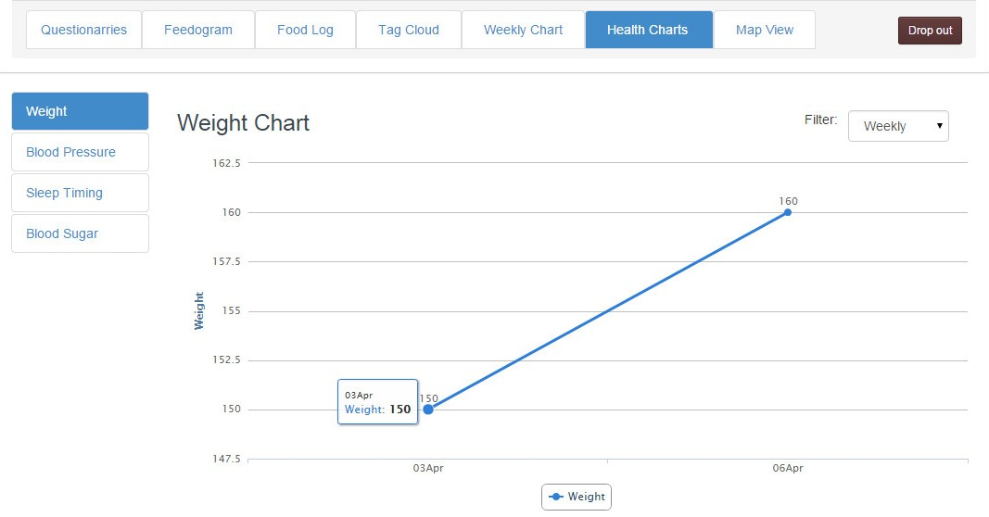

Coordinator can view the weight graph of the participant by clicking on “Weight Tab” as shown in the image above.

## 13.2 Blood Pressure

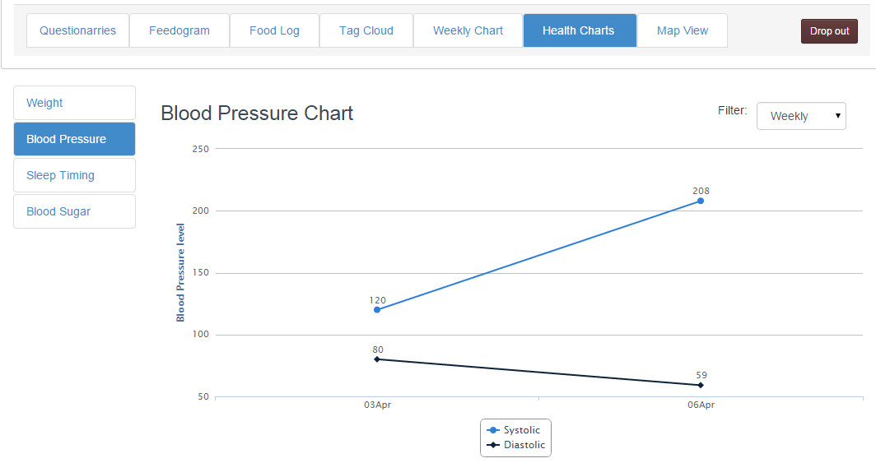Coordinator can view the Blood Pressure graph of the participant by clicking on “Blood Pressure Tab” as shown in the image above.

## Sleep Timing Chart.jpg13.3 Sleep Timing

Coordinator can view the sleep timing graph of the participant by clicking on “Sleep Timing Tab” as shown in the image above.

## Blood sugar chart.jpg13.4 Blood Sugar

Coordinator can view the Blood Sugar graph of the participant by clicking on “Blood Sugar Tab” as shown in the image above.

# map view.jpg14.0 View Maps

Coordinator may view the map which will display the place where the participant had taken his food.

# 11.jpg15.0 View Calendar

The coordinator can view this calendar to keep him informed about the appointments which he has today and in future. An option is provided on top right hand corner where he can view month wise, week wise, day wise.

# 16.0 View Blood Collection Centers

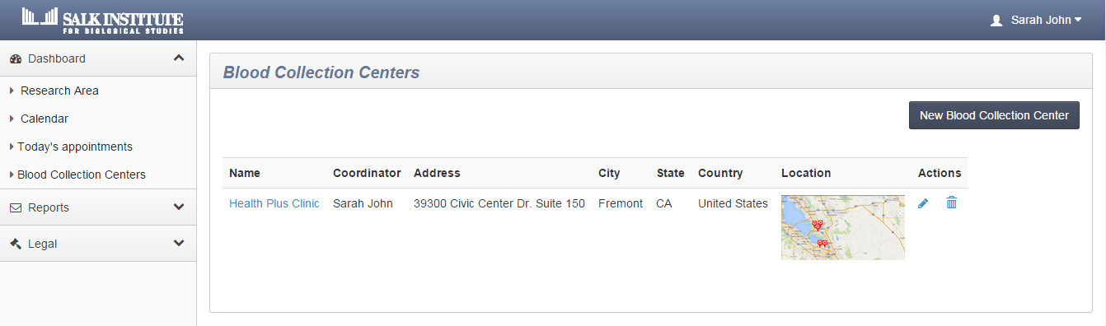The coordinator can view Blood collection Centers here. He will also have an option to edit or delete the center. There is also an option to add new Blood collection center. This will be explained in the subsequent image

## 16.1 Add New Blood Collection Center

|  |  |
| --- | --- |
| Form Name | New Blood Collection Centre |
| Form to be Used by | Coordinator |
| Form Functionality | The Coordinator will be able to create a new blood collection centre using this form. He has to enter details such as name of the collection centre, address, city, state, country and upload a .jpg file containing the direction of the location. |
| Form Output | The form has two buttons “Create Blood collection Centre” and “Cancel”. Output will depend upon the type of button clicked by the user. If first button is clicked then a new blood collection gets added and if later is pressed then form navigates a page back. |

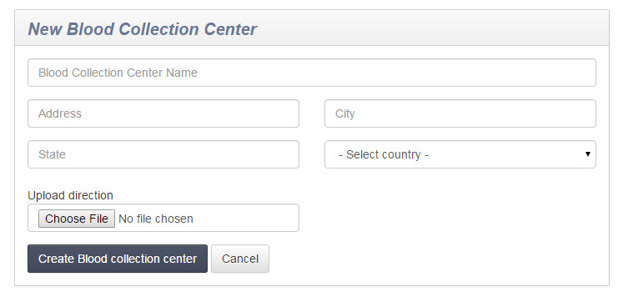

# 15.jpg17.0 View Reports

## 17.1 Daily Report

User needs to add email id as shown in the image above. Once that is done user may press the submit button.. All reports generated will be sent to user in his mail id daily.

## 17.2 Weekly Report

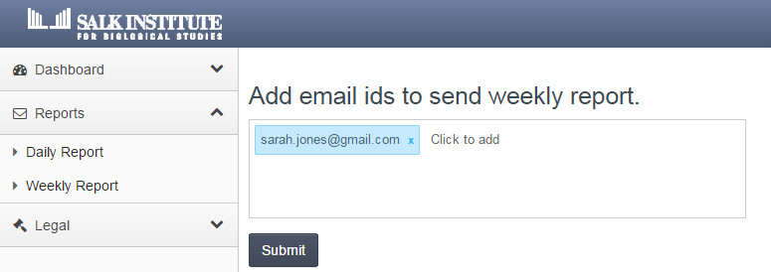

User needs to add email id as shown in the image above. Once that is done user may press the submit button. All reports generated will be sent to user in his mail id weekly